**Http session tracking technique using jsp**

Empform.html

<!DOCTYPE html>

<html>

<head>

<title></title>

<meta http-equiv="Content-Type" content="text/html; charset=UTF-8">

</head>

<body bgcolor="cyan"><center>

<form action="HttpSessionEx.jsp">

Enter Employee Name:<input type="text" name="ename"><br><br>

Enter Employee Designation:<input type="text" name="edesig"><br><br>

<input type="submit" name="send">

</form></center>

</body>

</html>

HttpSessionEx.jsp

<body bgcolor="green">

<center>

welcome to This Application<br><br>

<%

String name=request.getParameter("ename");

String design=request.getParameter("edesig");

HttpSession sn=request.getSession();

out.println("Your session id is"+sn.getId());

sn.setAttribute("empName",name);

sn.setAttribute("empDesign",design);

String e_name=(String)sn.getAttribute("empName");

String e_design=(String)sn.getAttribute("empDesign");

out.println("Employee Name is\t"+e_name);

out.println("<br><br>");

out.println("Employee Designation is\t"+e_design);

%>

<br><br><a href="empform.html">new form</a><br><br>

Thank you for Visiting this application<br><br>

have a nice day<br><br>

Bye Bye

</center></body>

Output:

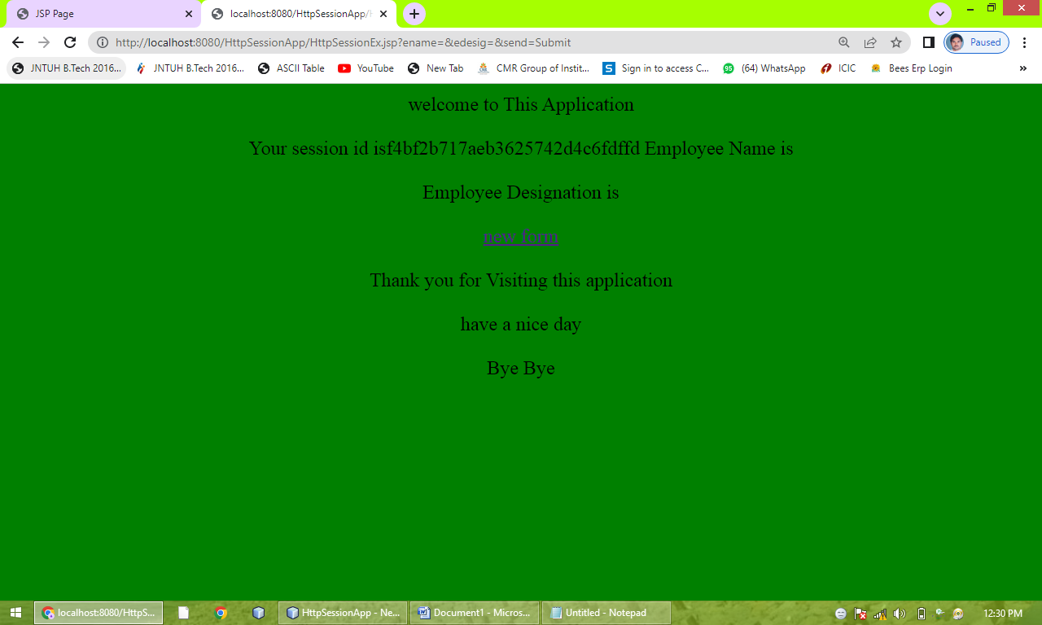

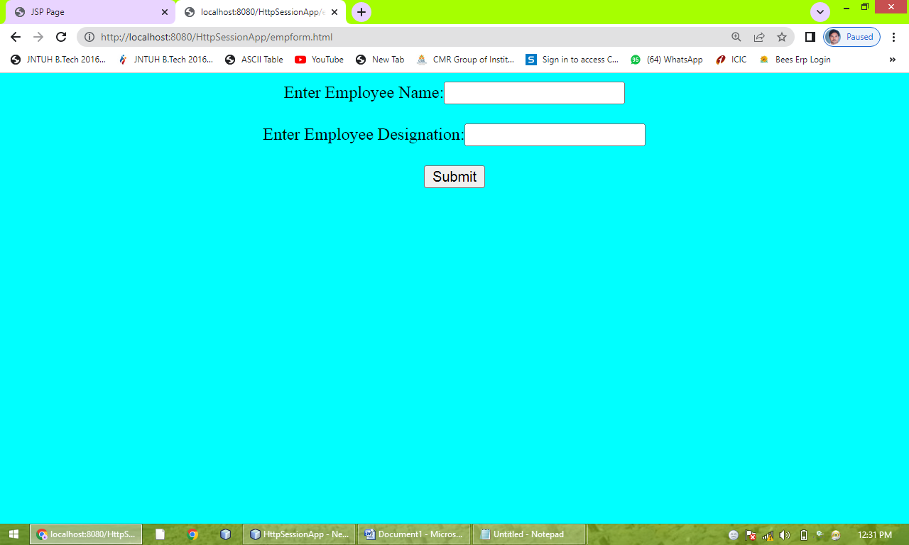

**Servlet with database connection**

Mysql.java

import java.io.IOException;

import java.io.PrintWriter;

import javax.servlet.ServletException;

import javax.servlet.http.HttpServlet;

import javax.servlet.http.HttpServletRequest;

import javax.servlet.http.HttpServletResponse;

import java.sql.*;

import java.util.logging.Level;

import java.util.logging.Logger;

public class MysqlServlet extends HttpServlet {

protected void doget(HttpServletRequest request, HttpServletResponse response)

throws ServletException, IOException, ClassNotFoundException, SQLException {

response.setContentType("text/html;charset=UTF-8");

PrintWriter out = response.getWriter();

try {

Class.forName("com.mysql.jdbc.Driver");

Connection con=DriverManager.getConnection("jdbc:mysql://localhost:3306/mydatabase","root","");

out.println("Connection established syccessfully<br><br>");

PreparedStatement stmt=con.prepareStatement("insert into student values(?,?)");

stmt.setString(1,"suresh");//1 specifies the first parameter in the query

stmt.setString(2,"CSE");

int i=stmt.executeUpdate();

out.println(i+" records inserted");

} finally {

out.close();

}

}

}

Web.xml

<?xml version="1.0" encoding="UTF-8"?>

<web-app version="3.0" xmlns="http://java.sun.com/xml/ns/javaee" xmlns:xsi="http://www.w3.org/2001/XMLSchema-instance" xsi:schemaLocation="http://java.sun.com/xml/ns/javaee http://java.sun.com/xml/ns/javaee/web-app_3_0.xsd">

<servlet>

<servlet-name>MysqlServlet</servlet-name>

<servlet-class>MysqlServlet</servlet-class>

</servlet>

<servlet-mapping>

<servlet-name>MysqlServlet</servlet-name>

<url-pattern>/MysqlServlet</url-pattern>

</servlet-mapping>

<session-config>

<session-timeout>

30

</session-timeout>

</session-config>

</web-app>

Output:

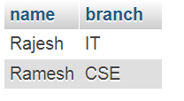

Record inserted

**Reading servlet parameters**

Form.html

<!DOCTYPE html>

<html>

<head>

<title></title>

<meta http-equiv="Content-Type" content="text/html; charset=UTF-8">

</head>

<body bgcolor="cyan">

<form action=SevletEx1>

Eneter Employee Name<input type="text" name="ename"><br><br>

Enter Employee ID<input type="text" name="eid"><br><br>

Enter Employee Designation<input type="text" name="edesig"><br><br>

<input type="submit" name="send">

</form>

</body>

</html>

servletEx1.java

import java.io.IOException;

import java.io.PrintWriter;

import javax.servlet.ServletException;

import javax.servlet.http.HttpServlet;

import javax.servlet.http.HttpServletRequest;

import javax.servlet.http.HttpServletResponse;

public class SevletEx1 extends HttpServlet {

protected void processRequest(HttpServletRequest request, HttpServletResponse response)

throws ServletException, IOException {

response.setContentType("text/html;charset=UTF-8");

PrintWriter out = response.getWriter();

try {

String empname=request.getParameter("ename");

String empID=request.getParameter("eid");

String empDesig=request.getParameter("edesig");

out.println("<html>");

out.println("<head>");

out.println("<title>Servlet SevletEx1</title>");

out.println("</head>");

out.println("<body bgcolor=yellow>");

out.println("<h1>This is my servlet project</h1>");

out.println("<h2>welcome to Mr/Mrs.\t"+empname+"</h2>");

out.println("<h2>Your Employee Id is\t"+empID+"</h2>");

out.println("<h2>Your Designation is \t"+empDesig+"</h2>");

out.println("<h2>You have successfully completed your project</h2>");

out.println("<h2>Have a nice day</h2>");

out.println("<h2>Bye Bye</h2>");

out.println("</body>");

out.println("</html>");

} finally {

out.close();

}

}

}

